Automated Video Quality Analysis Using Deep Learning

Yashas Dewan
Department of Data Science and Business Studies
SRM Institute of Science and Technology, Kattankulathur
Chennai, India
yd7336@srmist.edu.in
Dr.G.Vadivu
Professor
Department of Data Science and Business Studies
SRM Institute of Science and Technology, Kattankulathur
Chennai, India
vadivug@srmist.edu.in
Mihir Singh Malik
Department of Data Science and Business Studies
SRM Institute of Science and Technology, Kattankulathur
Chennai, India
mm5252@srmist.edu.in

Abstract— Video streaming is a common service utilized in today's times, ranging from popular platforms such as Netflix, Disney, and Amazon Prime to live video calls facilitated by WhatsApp and FaceTime. Given the growing computational capabilities and the imperative of delivering optimal end-user experiences, there arises a necessity to develop methods for testing and analyzing the video quality of streaming content. In our research, we propose a method for analyzing the same as well as a substantial publicly available dataset comprising thousands of distorted frames. We employ a Convolutional Neural Network (CNN) to train a model for discerning whether a frame in a video input is glitched or not, addressing the imperative of ensuring seamless video playback and enhanced user satisfaction.
Keywords— classification, Neural Network, Video quality

Introduction
Integrated deep learning (DL) techniques have led to a dramatic paradigm shift in modern society, increasing cognitive capabilities beyond traditional data analysis frameworks. With applications ranging from facial recognition to object classification, DL technologies have infiltrated various aspects of daily life, affecting how individuals interact with data more These technological advances extend beyond traditional boundaries, with the impact of DL feel more in areas whose applications go beyond traditional data processing models focused on a growing sector, exemplified by the widespread adoption of video-based applications.
Over the past decade, entertainment consumption underwent a metamorphosis, spurred by the proliferation of video services such as YouTube, Netflix, and Hotstar while the democratization of data access allowed individuals to they come from different backgrounds ability to participate in these activities as major sources of enjoyment marked by an unprecedented mixture of sports and entertainment builds.
Furthermore, the increasing integration of artificial intelligence (AI) in sectors including home services and healthcare signals a broader technological revolution if smart Home systems and AI-driven healthcare solutions upcoming is an example of this paradigmatic change, highlighting the transformation that AI has the potential to enhance highlights everyday life experience. In addition, the continued development of media devices that boast unparalleled computing power heralds a new era of innovation and possibilities.

Literature Review

AI in video quality assessment
Sun et al. (2021), presented a study of video quality diagnostic technology based on AI and the Internet of Things. Their research focused on color fade detection and video noise detection, demonstrating the clear impact of AI algorithms on video quality detection

AI and video production
Integrating AI into video production and distribution has been a recent trend. Jayanthiladevi et al.and others. (2020) highlights the developmental trend of video technology developments with machine learning and AI advances.

AI Tools for Video Quality Assessment
AI tools have been widely used for video quality assessment. They provide a way to optimize the flow to match available resources and explore different video parameter settings to optimize live video (Sharrab, Alsmadi, & Sarhan, 2022).

Influence of New Media Technology on Video Content Production
The emergence of new information technologies has been great. Video influenced production. This has led to the creation of a new generation of video applications that are gaining popularity worldwide (Lu & Nam, 2021).

Survey of deep learning-based video compression
The paper provides insights into deep learning techniques using image video compression, highlighting advances in sensitivity quality optimization This includes combining AI with conventional compression algorithms to achieve compression optimal design while maintaining a high-quality visual.

Unsupervised Learning-Based Video Quality Assessment With Feature-Attention Network.
The research provides an unsupervised learning-based study The method is video quality analysis, which incorporates a feature-attention network to dynamically highlight informative locations in videos This method demonstrates the power of AI-controlled methods in perceptual quality good capture of the.

RESEARCH PROBLEM
The study aims to improve the overall quality of video content production through the development and implementation of a comprehensive video quality assessment framework. In an era where video content has become ubiquitous across platforms and industries, maintaining consistency, meeting industry standards, provide a quality user experience, are key concerns of the challenges of producers and organizations and contribute to the development of sustainable video production practices.

Through intensive research and analysis, our study seeks to identify key areas for improvement in the existing system. It includes examining current practices, tools, and technologies used in video quality assessment, as well as exploring emerging trends and innovations in the field with a broader understanding of the strengths and limitations it is in the existing channels.

An important aspect of the research objective is the development of a program for video quality testing that integrates state-of-the-art techniques and best practices. In addition to complex deep learning algorithms that can detect and analyze a wide range of quality issues from visual artifacts and compression errors to audio distortion and synchronization problems, the implementation will include automated workflows and intuitive interfaces to be used to simplify the quality assurance process and facilitate easy collaboration in production.

Methodology

The general design and functional flow of our suggested
video quality analysis system are presented in this section. The framed glitch generator, the Model classifier, and the dataset are the three main parts of the system.

Dataset Description
Our dataset consisted of 18,000 individual frames from 17 videos. This dataset is divided into two distinct subsets: "Glitched" and "Not Glitched". The "glitched" subset includes a variety of noises and glitches; below mentioned are a few.
- Laplacian transformation: We used this technique, which derives from the Laplace distribution, to induce discontinuities, such as sudden dynamic changes in pixel values.
- Salt and Pepper Noise: We simulate high-speed noise in digital media by introducing random white and black pixels that resemble salt and pepper sprinkles on the image.
- Noisy changes: By injecting Gaussian noise, we often simulated the subtle changes seen in the images, which increased the diversity and robustness of our dataset.
- Adaptive Change: Using storm simulation techniques, we simulated the atmospheric drag, making it look like blurry images taken in the rain.
By integrating these variables, our dataset reveals the types of anomalies encountered in real-world situations, facilitating a comprehensive analysis of image-processing tasks.
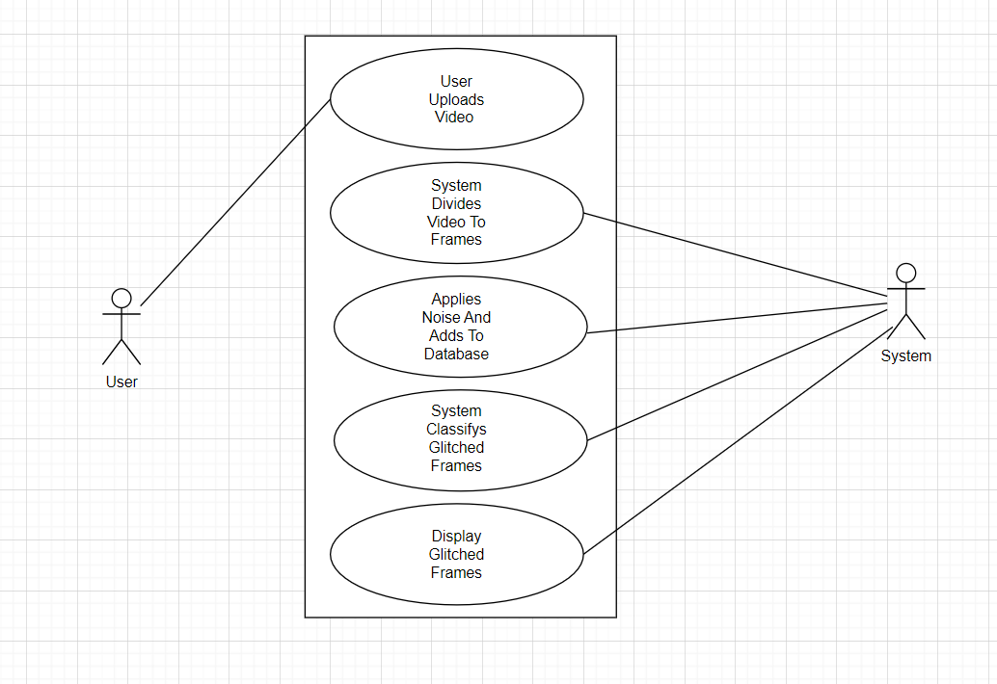
Fig. 1 Use Case Diagram

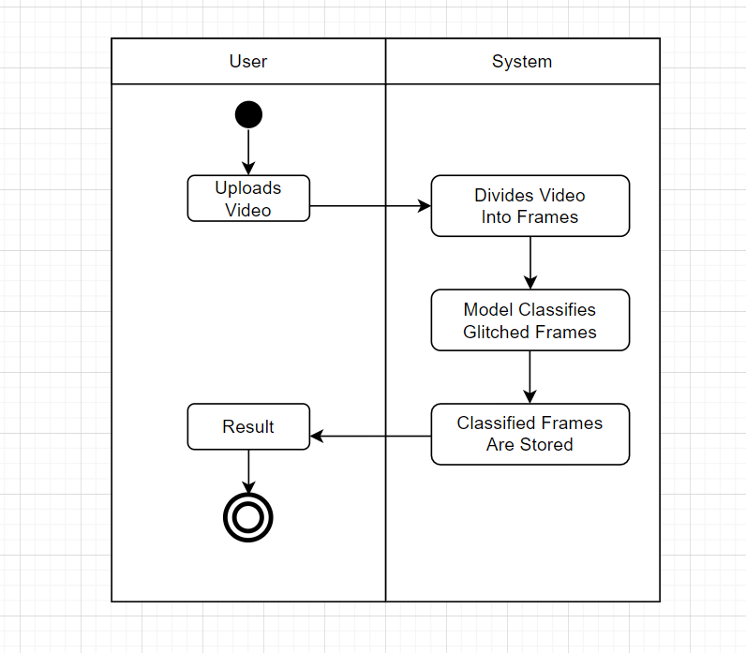
Fig. 2 Activity Diagram

Dataset Generation
To form our dataset, we procured 10 video files in the.mp4 format. We first converted these videos into individual frames. We then employed a random selection process, subjecting 20% of these frames to various types of noise and glitches using Laplacian functions and Python libraries. This step aimed to introduce variability and challenge to the dataset. Ultimately, our dataset consists of two distinct classes: glitched and non-glitched, each comprising 18000 individual images.

Proposed algorithm
- Video Acquisition and Storage: The system collects user videos via a Flask web interface and stores them locally.

- Frame Extraction and Storage: The system extracts frames from the dataset. Expansion: We randomly select 20% of the training dataset to add glitches and noises through vector operations.

- Frame Classification: A Convolutional Neural Network (CNN) classifies each frame, whether original or augmented, to determine its glitch status.

- Results Presentation: The system displays the classification results to users, indicating glitched frames and offering a qualitative assessment of video quality.

- Quantification of Glitchiness: As an enhancement, the system aims to quantify glitch severity, providing users with a numeric measure of video degradation for informed decision-making.

Classification
Convolutional neural networks (CNNs) have emerged as pivotal tools in AI-driven video quality analysis. In this study, we evaluate the performance of three prominent CNN architectures—VGG19, MobileNet, and ResNet-101—for the classification of video frames based on their quality. Utilizing transfer learning, we initialize these models with pre-trained weights obtained from extensive datasets such as ImageNet. To adapt these models to our task, we replace the final fully connected layer to output two neuron activations, distinguishing between "glitched" and "non-glitched" frames. Our dataset comprises 18,000 images extracted from video frames, encompassing a diverse range of anomalies and distortions commonly encountered in real-world scenarios. These images are resized to 256x256 pixels to serve as input to the models. The training process involves optimizing the models using the Adam optimizer and binary cross-entropy loss function over multiple epochs. We partition the dataset into training, validation, and test sets, with 70%, 20%, and 10% of the data respectively, ensuring robust model evaluation. The models are evaluated using evaluation metrics including accuracy, precision, recall, and F1-score on blinded test sets. Our method employs deep CNNs and transfers learning to efficiently and effectively classify video frames, thus contributing to the advancement of automated video quality analysis systems.

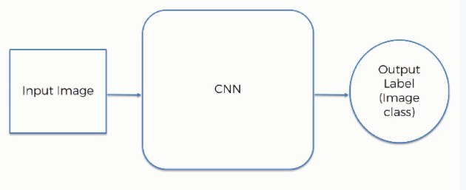
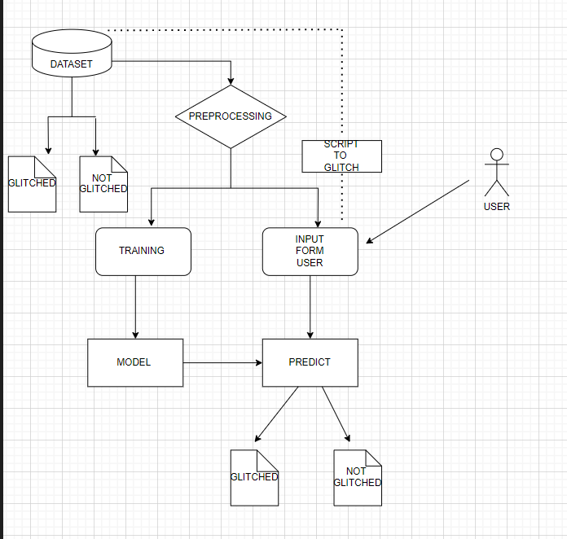
Fig. 4 CNN Architecture

Results and discussion
The deep learning model achieved impressive results in real-time video classification showing robustness and efficiency in accurately classifying video frames for clutter and noise. Training the model with curated datasets led to an overall accuracy of 99.7%. Furthermore, the model demonstrated exceptional performance in all video formats like real-time, animated,3d videos.

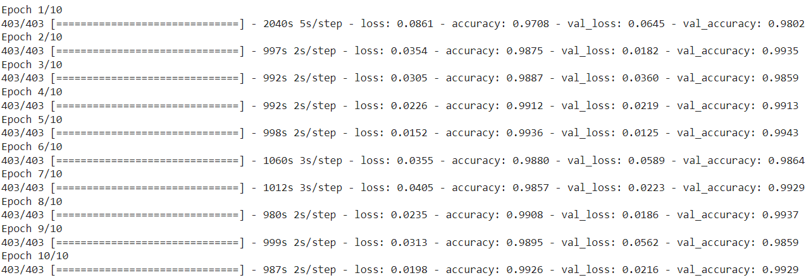
Fig.7. Accuracy prediction of the model

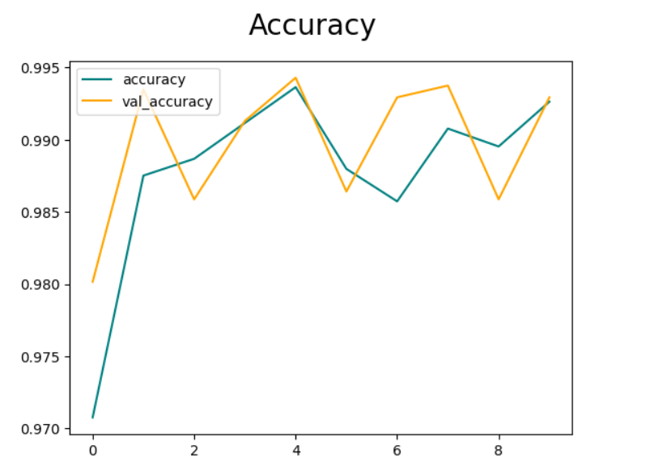
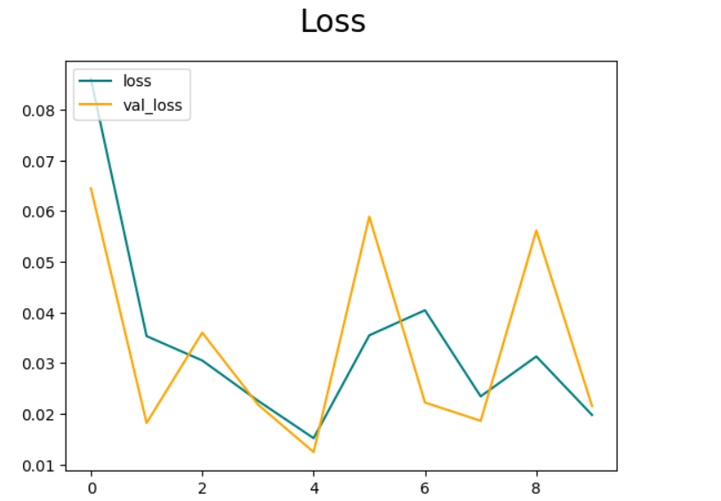
Fig. 5 Home Page

Fig. 6 Registration Page

Fig. 7 Login Page


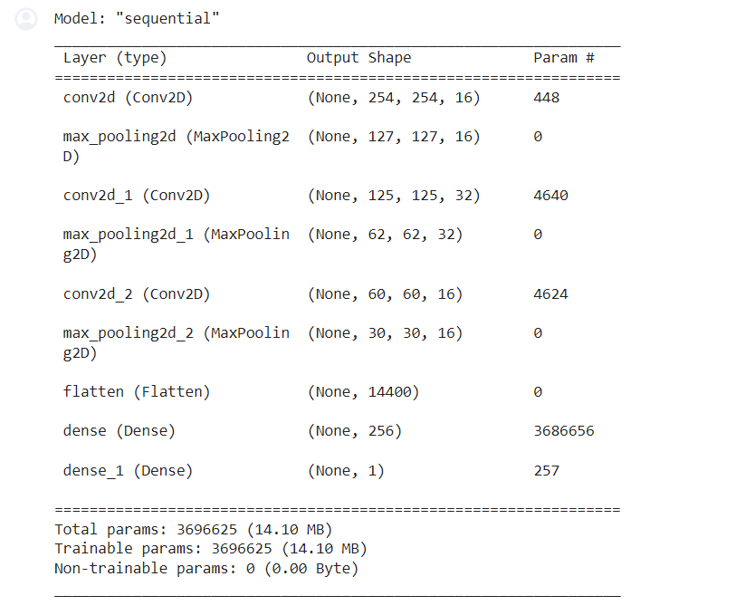
Fig. 8 Image Uploading



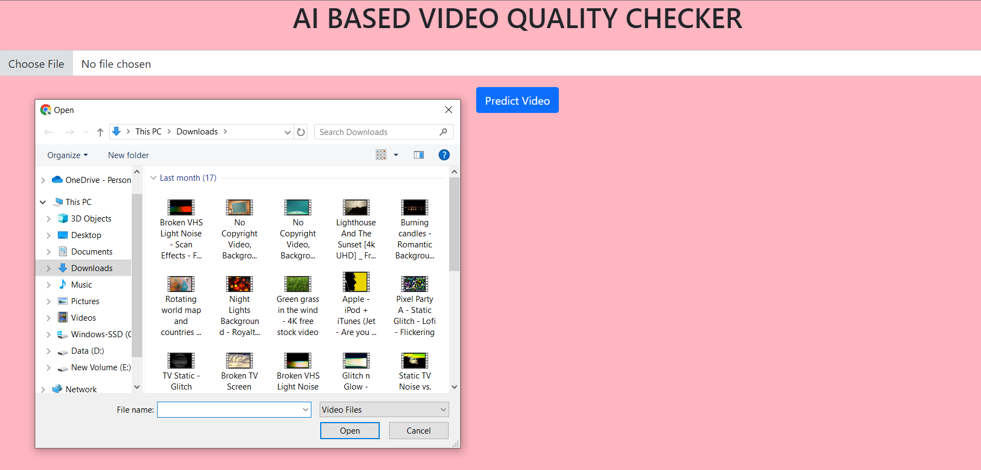


Fig. 9 Predicted Output Garbage as Paper
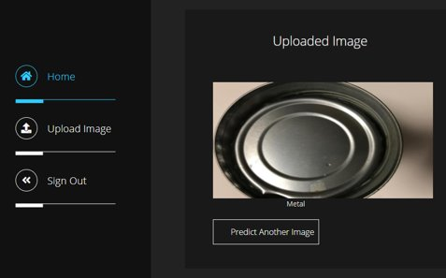
Fig. 10 Predicted Output Garbage as Metal

The results obtained underscore the efficacy of deep learning methodologies in addressing the complex task of household waste classification. The high accuracy, precision, and recall rates indicate the model's ability to effectively discern subtle differentiations between various waste categories, thereby facilitating efficient waste management practices. The utilization of a diverse and carefully curated dataset played a pivotal role in enhancing the model's generalizability and ensuring its applicability to real-world waste sorting systems. The superior performance of the deep learning model, as compared to traditional machine learning algorithms, emphasizes the importance of leveraging deep learning techniques for complex image classification tasks. The multi-layered architecture of the convolutional neural network enabled the extraction of intricate features. Through thorough analysis and evaluation, we have successfully identified and addressed various aspects affecting video quality, including resolution, compression artifacts, color accuracy, and audio clarity. By implementing this program, we can confidently guarantee an optimal viewing experience for our audience while maintaining consistency and professionalism across all multimedia platforms. Moving forward, continuous monitoring and improvement of our video content quality.

Conclusion
In conclusion, the usage of AI-driven video quality analytics indicates promising capability for revolutionizing video content analysis and optimization throughout various fields and technologies. We offer superior and newer methods using deep learning and knowledge of, our research demonstrates the tremendous accuracy, precision, and charge of the version for spotting the complex nuances and glitches of video frames. Careful management of datasets, including error types and noise, plays an important role in confirming the model’s robustness and real-world application Moreover, deep learning methods are superior to traditional algorithms. It highlights the transformative potential of AI in the processing of image-classification task

Future Work
Considering future efforts, extending our model to accommodate real-time video streaming presents an interesting approach to improve video quality assessment. While our current system competently handles uploaded video files, its extended capability to handle live streaming with ease poses a significant but promising challenge Through real-time processing capabilities and adaptive by integrating algorithms, we can empower our model to dynamically analyze streaming content Also can be pre-embedded directly in hardware such as tv and smartphones to predict video quality before production and for the user use information about the causes and solutions to make it better therefore improving the overall user experience.

Reference

- Jayanthiladevi, A, AG Raj, R Narmadha. (2020). “AI in video analysis, production, and streaming delivery”.
- Sun, Z, J Sun, X Li. (2021). “Research on Video Quality Diagnosis Technology Based on Artificial Intelligence and Internet of Things. Wireless Communications and Mobile Computing”.
- Zhou, W., Zou, J., Chen, C., & Chen, C. W. (2021). Unsupervised Learning-Based Video Quality Assessment With Feature-Attention Network.
- Huang, Y., Luo, Z., Zhang, Y., & Huang, T. (2021). Deep learning for video coding: A review. Kuchaiev and B. Ginsburg, “Factorization tricks for LSTM networks,” 2016
- Zhang, K., Sun, X., & Ma, S. (2020). Learning-based Video Coding: A Comprehensive Review.
- A. Krizhevsky, I. Sutskever, and G. E. Hinton, “ImageNet Classification with Deep Convolutional Neural Networks,” ImageNet Classif. with Deep Convolutional Neural Networks, (2012) 1097– 1105.
- G. N. P. d. Santos, P. V. A. de Freitas, A. J. G. Busson, A. L. ´ Guedes, R. Milidiu, and S. Colcher, “Deep learning methods for video ´ understanding,” in Proceedings of the 25th Brazillian Symposium on Multimedia and the Web, 2019.
- B. Rajesh, M. Javed, Ratnesh, and S. Srivastava, “Dct-compcnn: A novel image classification network using jpeg compressed dct coefficients,” 2019.
- Sheikh, H. R., & Bovik, A. C. (2006). Image information and visual quality.
- R. Yang, M. Xu, and Z. Wang, “Decoder-side have quality enhancement with a scalable convolutional neural network,” in 2017
- R. Yang, F. Mentzer, L. V. Gool, and R. Timofte, “Learning for video compression with hierarchical quality and recurrent enhancement”.
- C. Liu, L. Sharan, E. H. Adelson, and R. Rosenholtz, “Exploring features in a Bayesian framework for material recognition”.
- S. Li, F. He, B. Du, L. Zhang, Y. Xu, and D. Tao, “Fast spatio-temporal residual network for video super-resolution” 2019.
- B. Batinic, S. Vukmirovic, G. Vujic, N. Stanisavljevic, D. Ubavin, and G. Vukmirovic, “Using ANN model to determine future waste characteristics in order to achieve specific waste management targets -a case study of Serbia,” J. Sci. Ind. Res. (India)., 2011.
- C. Dong, C. C. Loy, K. He, and X. Tang, “Image super-resolution using deep convolutional networks,” 2015.
- V. Verma, N. Agarwal, and N. Khanna, “Dct-domain deep convolutional neural networks for multiple jpeg compression classification,”l 2018.

